Editing on website pages – Web pages(Windows)
1. Home page –
a. Login and signup tabs should be presentable, in attractive color matching with the website theme. Giving references below.

 is to be added on the home page.
b. The bar is looking very dull. Make the size and color attractive.

c. Write “Student” and “School” instead of 2xcell for student and 2xcell for school.
d. There should be 4 images on the home page scrolling continuously one by one.
1. Hybrid Learning
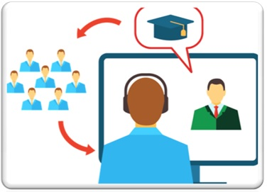

Hybrid learning methodology combines traditional classroom experience, experiential learning and digital tools and courses to bring effective and sustainable learning outcomes.
2. Personalized online learning classes:
Change the image:

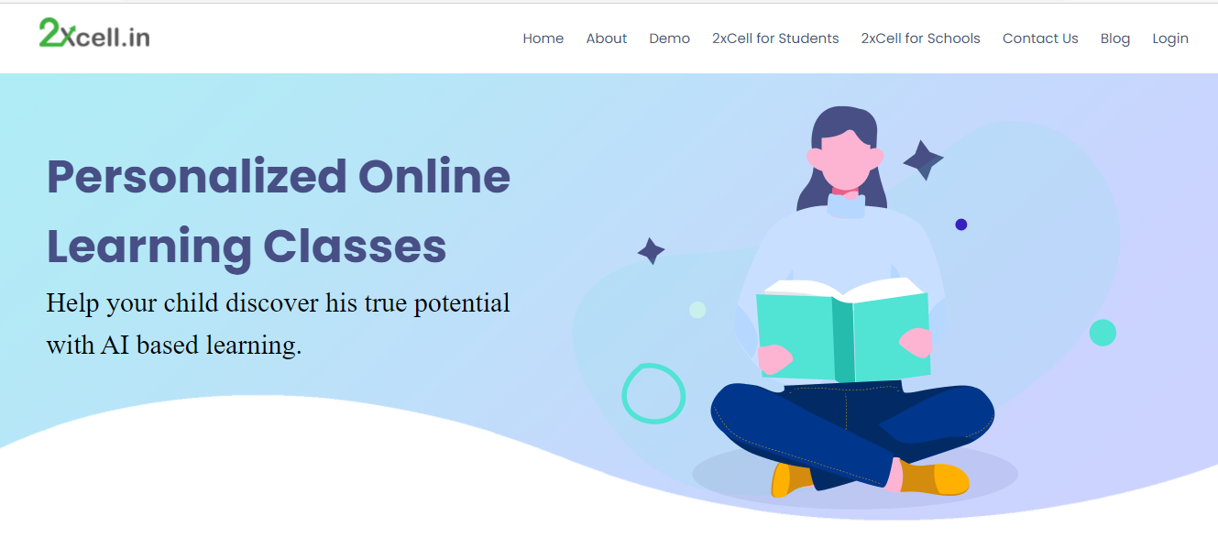
c. Coding and Computational thinking (take from the current website)
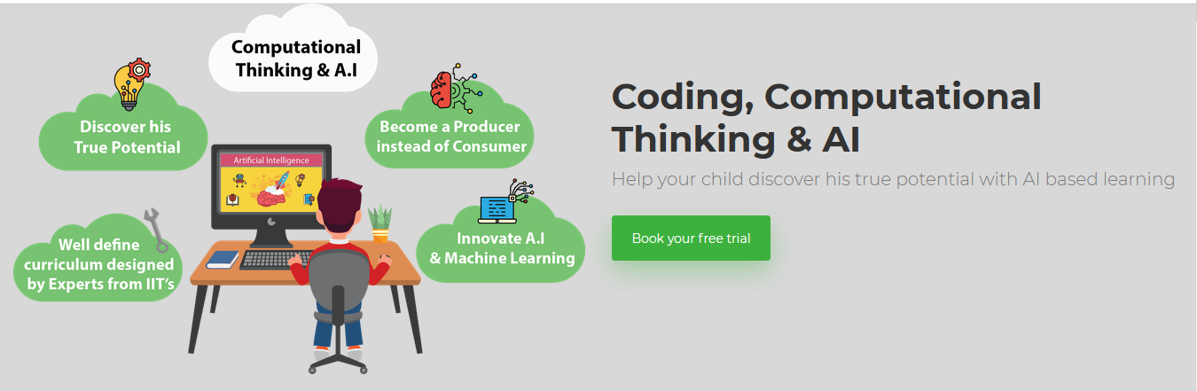
4. Master the art of communication - (take from the current website)
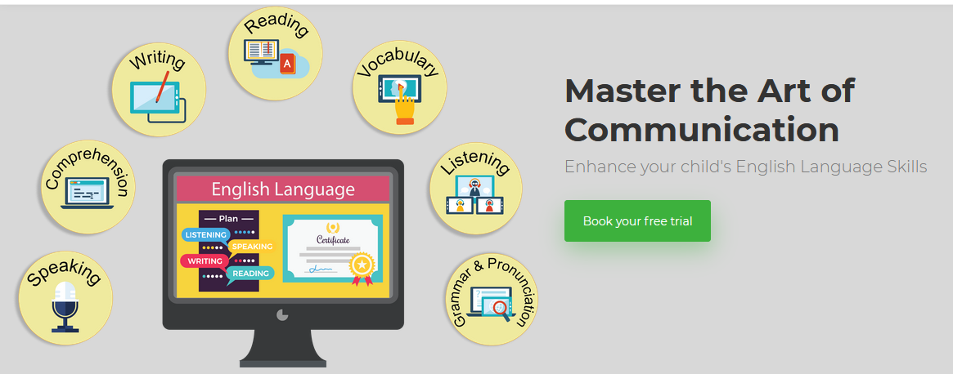

e. Add in this section.
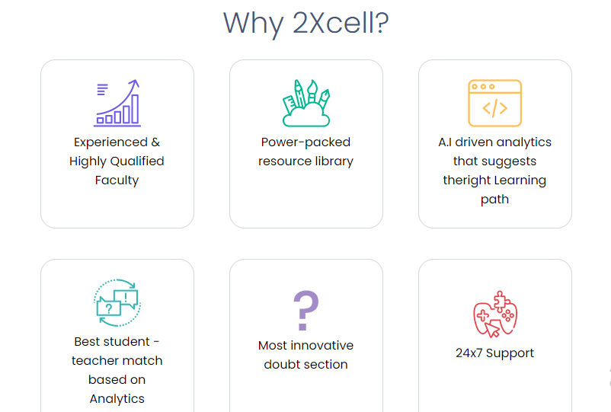
1. Hybrid classroom – It should be first
 Online and offline class sync

2. Assessment Engine – It will be on 3rd position.
Evaluation of learning outcomes and gaps.

3. Class Insights – This will be on 6th Position.
Capturing real time class engagement and activity


f. Add grade in this section. The overall size of the complete section should be reduced, its appearing too big on the desktop screen.
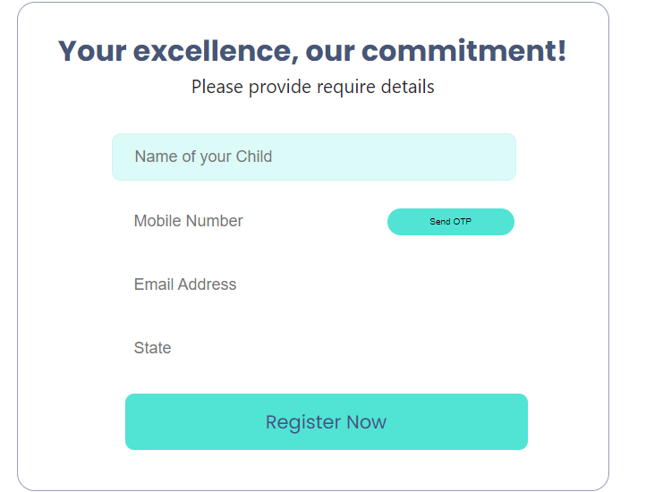

g. Link the promotional video of 2xcell (take this from the existing website)
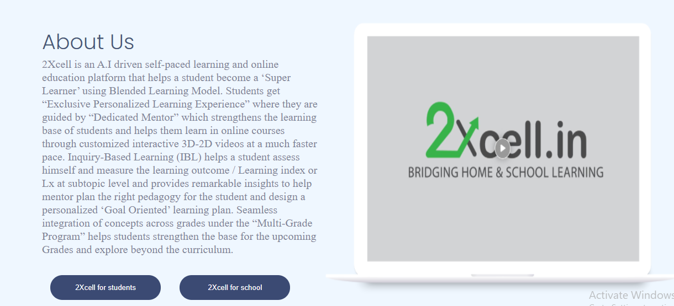
h. Remove the text highlited below. Reduce the size of the all the content.
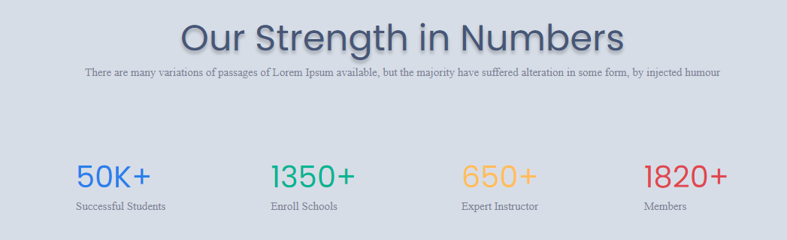
I . Link all the videos(take them from the current website)
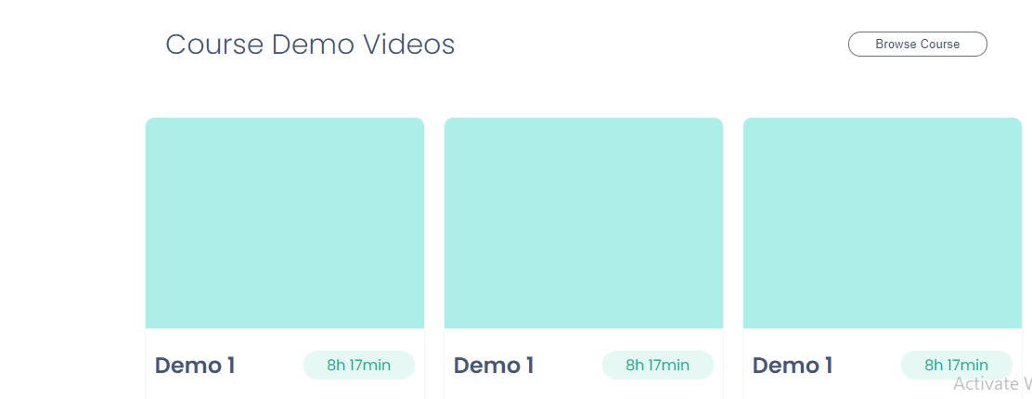

2. Demo Page:
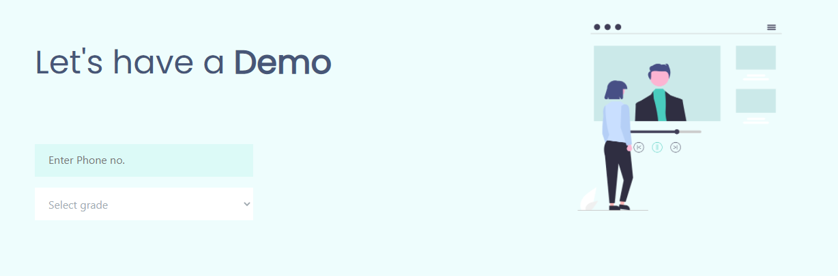
- No tabs appearing on the top, there is no logo, no option to move back to the home page.
- Make this presentable.
- Link all the demo videos classwise from the existing website.

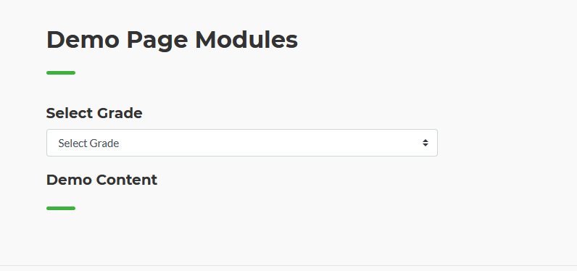
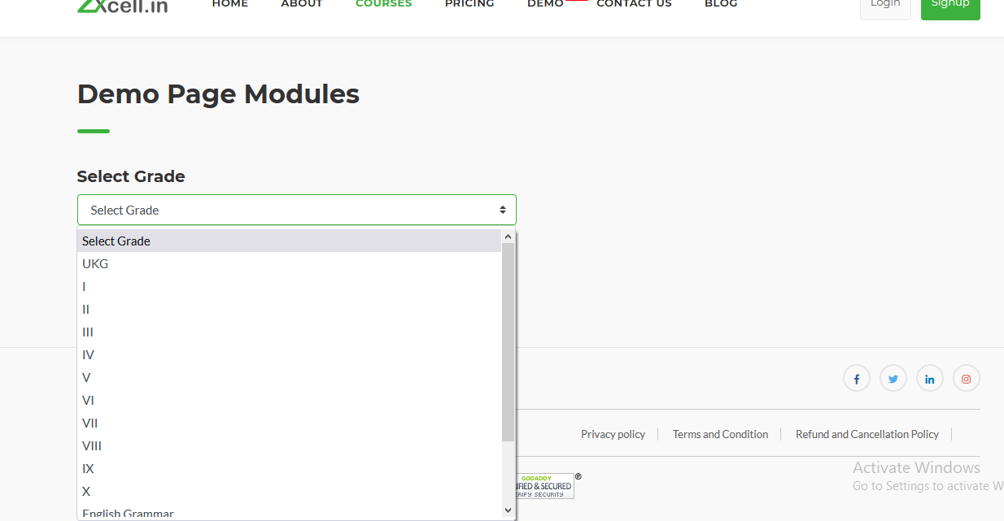

3. Student Page:
- Change the pic of student
- Add Hybrid classroom as a
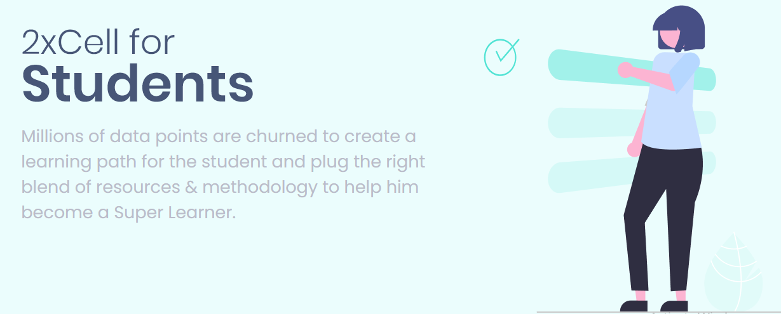



4. School page:
- Change the text, image and content on the School page.
- Add logo of 2xcell on the left side-
- The text to be added on school page:
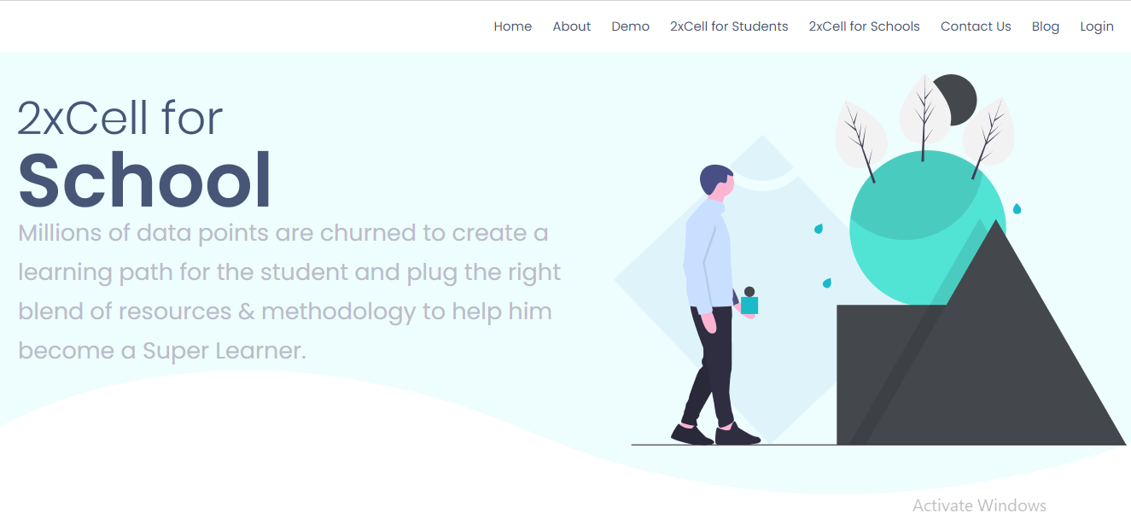
Change Pic

2xcell brings hybrid learning model for school. The aim is to provide blended learning, bridging the gap between online and the offline learning challenges.
Educators are empowered on 2xcell by getting the right digital tools they need in the classroom and easy their daily tasks.
Comprehensive AI drive analytics provides them the insights on the students regular performance, activities, learning goals and gaps. The analytics helps them to choose the learning model and theories to be used in for the class as a whole and for an individual student in order to incluclate self confidence and love for learning.
Digital learning resources, assessment engine, white board tools, lesson planner are provided to equip the school and educators for hybrid classroom and be ready for 21st century challenges.

2. If required you can use the image given below:

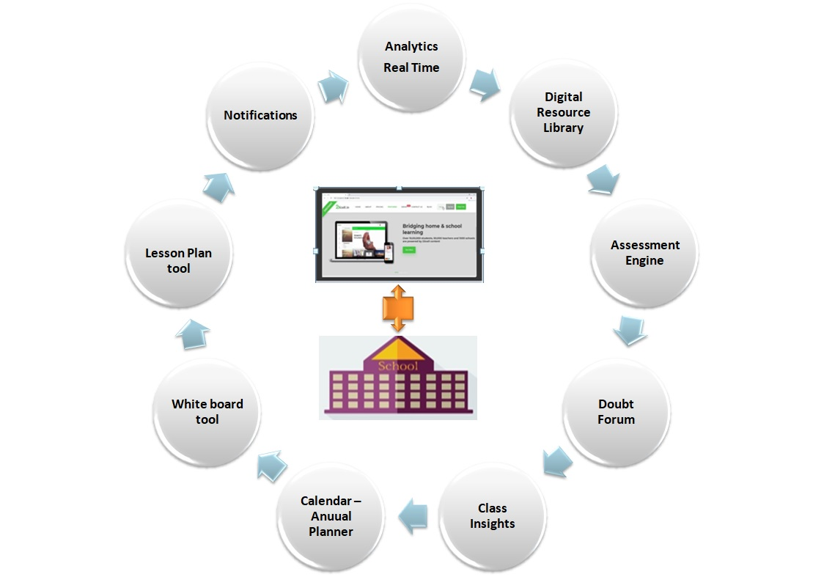

d. The below content and images size are to be reduced so that it appears properly and fully on the screen.
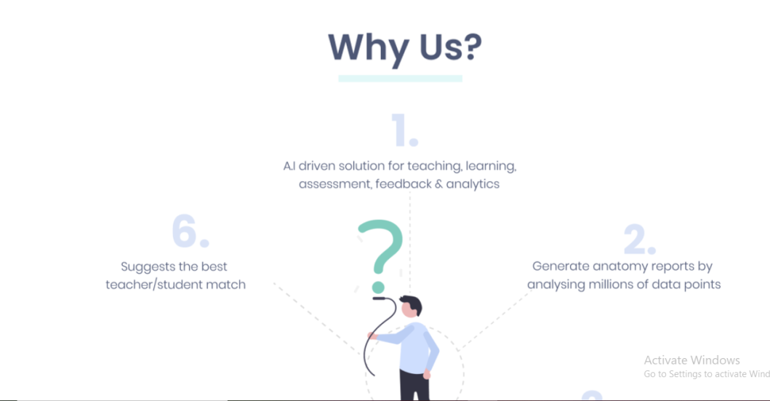
e. Points mentioned are to be arranged properly so that they look presentable.
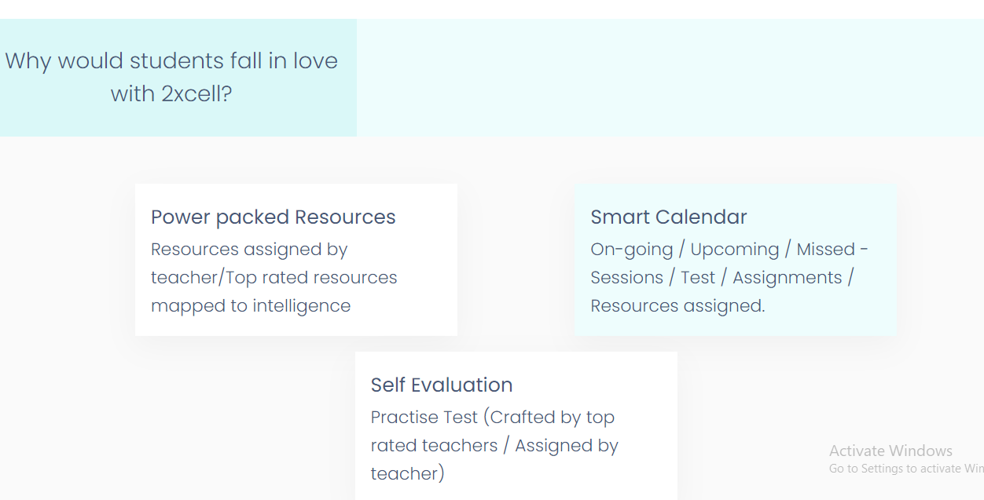
f. The points are repeating.
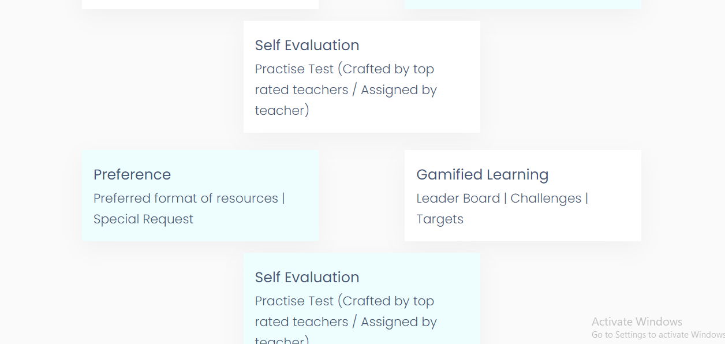

5. Contact Us:
- Change image
- Change address – 633-A, Udyog Vihar Phase-V, Gurugram, Haryana - 122015


6. Blog Page- Link all the blog available on current website.
7. Add all the tabs available at the bottom in the current website.
- Privacy policy
- Term and conditions
- Refund and cancellation
- Process
- Chat
